**FR CARA Tiny URLs**

FR CARA 2020 Trainee Demographic Form Only:<https://tinyurl.com/FRCARAdemog1>

Qr code FRCARA posttest only


FR CARA 2020 Trainee Posttest Form Only:

<https://tinyurl.com/FRCARAposttest1>

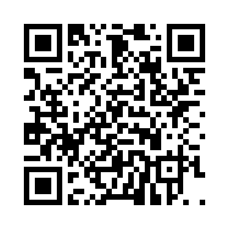

FR CARA Trainee Demographic and Posttest forms combined<https://tinyurl.com/FRCARATrainee>

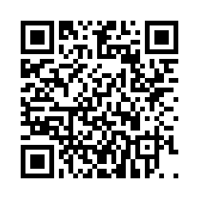

FR CARA Opioid Overdose Knowledge Follow-up

<https://tinyurl.com/FRCARAFollowup>

